**Data Analysis & Business Intelligence Made Easy with Excel Power Tools**

**Excel Data Analysis Basics = E-DAB**

**Notes for Video:**

**E-DAB-06-Power Query (Get & Transform) to Clean, Transform, Import Data**

**Outcomes for Video:**

1. What is Power Query? 2

2) Reminder of the goal of Data Analysis and why will need Power Query 2

3) Power Query history 3

4) If your data is in an Excel sheet 3

5) If you have data from an external source 4

6) If you ever need to edit, delete or look at your query 4

7) Clean Data with Power Query (Get & Transform), Flash Fill or formulas? 5

9) Every time we use Power Query, we create a new “Query” 5

10) Power Query uses “Data Types” for each Column / Field 6

11) Delimiter? 6

12) Why store data in Text Files? 6

13) Change Load Location 6

2. Example 1: PivotTable Gets New Source Text File Each Month 7

3. Example 2: Clean and Transform Bad Data For PivotTable 12

4. Example 3: Import Multiple Text Files 20

# What is Power Query?

* 1. What does Power Query do?
     1. **Import** Data from External sources
        1. External sources such as text files, folders that contains multiple files, Excel workbooks, SQL databases and more.
     2. **Clean** Data
        1. Like split data in a column into three columns
     3. **Transform** Data
        1. Like combining multiple tables into one Proper Data Set
     4. **Loads** Data to these locations:
        1. Excel Sheet = Data in cells in Excel Worksheet.
        2. PivotTable Cache = data in behind the scenes PivotTable Cache.
        3. Power Pivot Data Model = Data in behind the scenes Power Pivot Columnar Database (Data Model) which can hold millions of rows of data.
  2. Reminder of the goal of Data Analysis and why will need Power Query :
     1. Data Analysis:
        1. Converting Raw Data into Useful Information
     2. Proper Data Set:
        1. Field Names / Column Headers in first row
        2. Records in each row (sales transactions, employee records and so on)
        3. Empty cells all around data set (or Excel row or column headers)
     3. “Bad Data”
        1. “Bad Data” = Raw Data that is not in a Proper Data Set form.
        2. If we don’t have a Proper Data Set than we can use Excel Data Analysis features.
        3. So when we get “Bad Data”, we have to clean and transform the data so it becomes data that is stored in a Proper Data Set.
        4. Power Query (Get & Transform Data) is an Excel Feature that can clean and transform data.
     4. Importing Data:
        1. We do not always have our data in our Excel file.
        2. Power Query will allow us to import data from any source and then load it to our desired location (such as Excel Worksheet, PivotTable Cache or the Data Model)
  3. Power Query history :
     1. Power Query has been around since Excel 2013
     2. In Excel 2010 & 2013 Power Query was an add-in that you had to download and install
     3. In Excel 2016 Power Query become the “Get & Transform” group in the Data Ribbon Tab.
     4. Depending on the version of Excel that you have, the Get & Transform group looks different.
        1. If you have Office 365, your “Get and Transform Data” group may look like this:

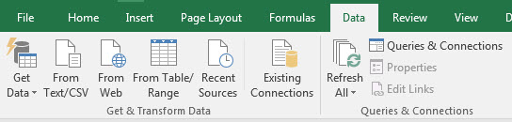

Or:

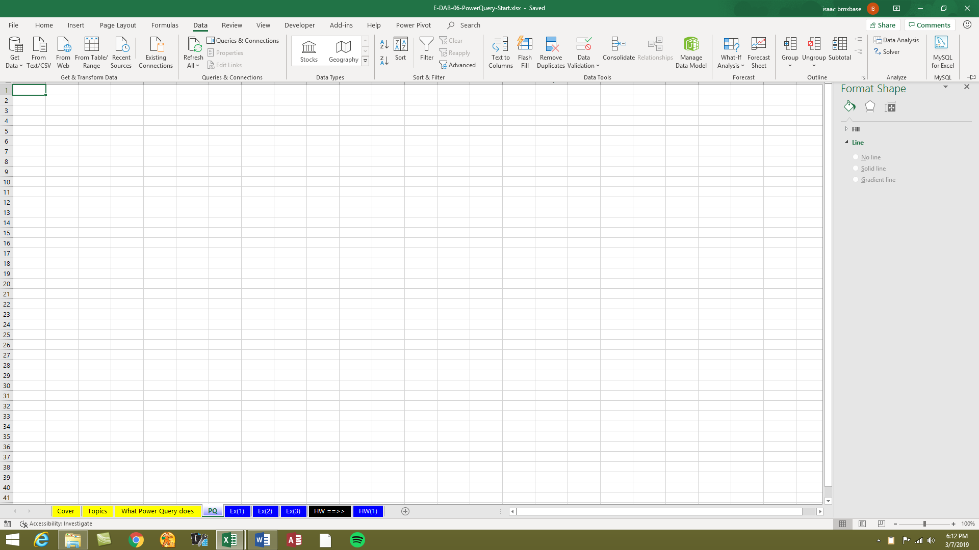

* + - 1. If you have Office 2016, your “Get and Transform” group may look like this:

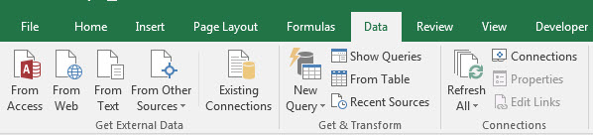

* 1. If your data is in an Excel sheet, you must convert the data to an Excel Table using the Excel Table feature.
     1. This is to ensure that if you add new data, the output from Power Query will update when new data is added.
     2. Then you click the “From Table” button in the Get & Transform group in the Data Ribbon Tab to put the Excel Data into the Power Query Editor:
        1. In Office 365 the “From Table/Range” button looks like this:



* + - 1. In a version that is Office 2016 the “From Table” button looks like this:



* 1. If you have data from an external source, we can begin the process of importing the data by clicking the following button:
     + 1. In a version that is NOT Office 365 to get external data click the “Get Data” button:



* + - 1. In a version that is NOT Office 365 to get external data click the “New Query” button:



* 1. If you ever need to edit, delete or look at your query, you must open the Query Pane. The button to click to open the Query Pane is in a different location depending on whether or not you have Office 365:
     1. In Office 365, you click the “Queries and Connections” button in the Queries and Connections group in the Data Ribbon Tab:



* + 1. In a version that is NOT Office 365, you click the “Show Queries” button in the Get & Transform group in the Data Ribbon Tab:



* + 1. If you ever need to edit or look at your query, you can double-click the query in the Query Pane. You can right-click the query and point to edit also.
    2. If you need to delete your query and start over, you can delete the query in the Queries Pane.
  1. Clean Data with Power Query (Get & Transform), Flash Fill or formulas?
     1. Use Flash Fill when the data cleaning is a one-time event and you don’t need the solution to update when the source data changes.
     2. Use Formulas when the data cleaning solution needs immediately update when the source data changes.
     3. Use Power Query when you need the solution to update after you click the Refresh button.
  2. Other reasons to use Power Query rather than Flash Fill, Formulas and other methods of cleaning and transforming data:
     1. Power Query can be significantly easier when the cleaning is complicated or has multiple steps, especially as compared to formulas
     2. If the data is coming from an external source, Power Query can be significantly easier than any other method.
     3. If you have multiple files that you need to transform into a single Proper Data Set, like in the example in our video, Power Query is significantly easier than any other method.
     4. The “Query” created with Power Query an be linked to a reporting solution. And you are allowed to go back and edit that query at any time, and then simply refresh the report and it will reflect the changes made in the query.
  3. Every time we use Power Query, we create a new “Query”.
     1. The word “Query” means to ask a question.
     2. When we start a “Query” based on a Start or Begin Data Set, we are asking a question of the data set.
     3. For example:
        1. If our Start or Begin Data Set looks like this:

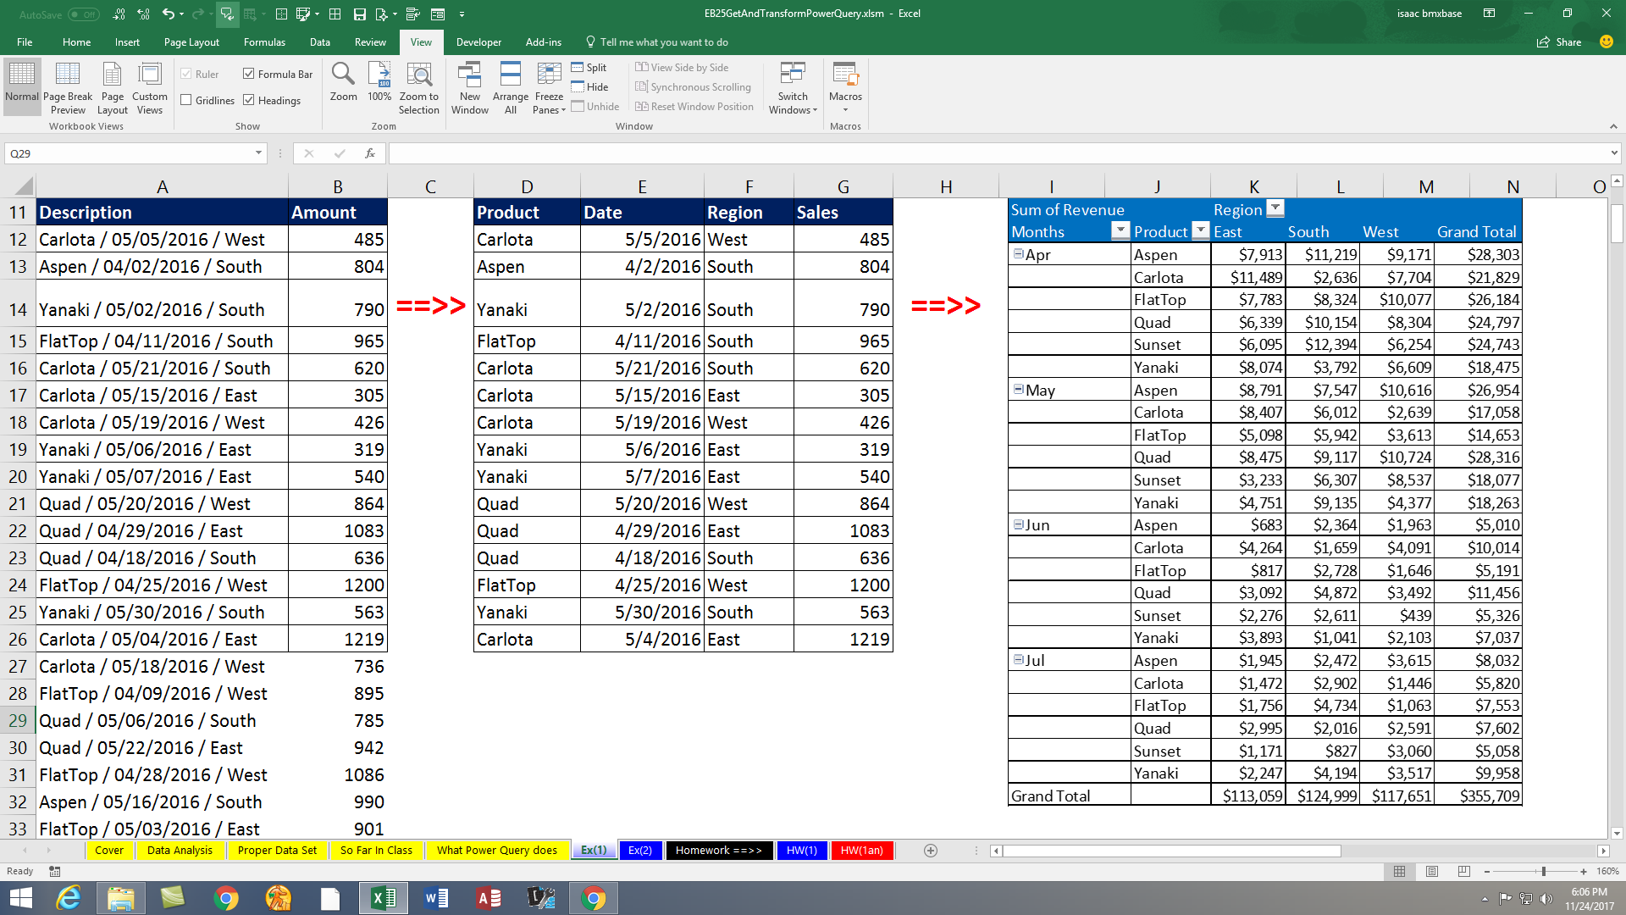

* + - 1. We might want to ask the question or “Query”: “Can I see the Description Column Split into three separate columns?”, where the answer to the “Query” would look like this:



* 1. Power Query uses “Data Types” for each Column / Field
     1. “Data Type” indicates what sort of data can go in a particular Field or Column.

For example, we may designate a column as one of these Data Types:

* + - * + **Text**: Where the column can only contain Text values
        + **Date**: Where the column can only contain Date values
        + **Whole Number**: Where the column can only contain Whole Numbers with no decimals
        + **Currency**: Where column can contain Currency amounts with up to 4 decimals
        + There are more Data Types also…
    1. When you designate a Column / Field as a specific data type, you are building a more robust data storage system, because you are assuring that the right kind of data goes into the column.
    2. Power Query and Access both use “Data Types”.
    3. ***Important***: If you do not choose the correct data type for each column, the data analysis features in Excel, like a PivotTable may not work correctly.

For example:

* + - * + A Date Field without the Date Data Type cannot group in a PivotTable.
        + A Sales Column without a number Data Type may not be able to be summed.

1. Delimiter?
   * 1. A delimiter is a character or set of characters that separate data that should be broken apart into separate columns

For example, for this data: Carlota / 05/05/2016 / West

* + - * + The delimiter is “ / “ (Space, Forward Slash, Space).
        + The delimiter tells us how the data should be split into separate columns.
        + The resultant data should be:



* 1. Why store data in Text Files?
     1. Because there are so many different systems for storing data, one of the common files types used to transfer data from one system to another system is the “Text File”.

Examples of Text File extensions:

* + - * + “.txt”
        + “.csv”

The Delimiters used for different text files:

* + - * + “.txt” uses a Tab as the delimiter
        + “.csv” uses comma as the delimiter
  1. Change Load Location:
     1. To change the Load locations (like change from PivotTable Cache to Excel Table in Worksheet), open Queries & Connections Pane, right-click query, click on “Load To…”, as seen here:

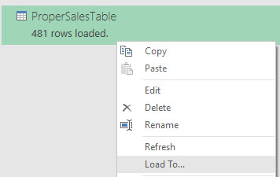

# Example 1: PivotTable Gets New Source Text File Each Month

* 1. From the Data Ribbon Tab, in the Get & Transoform Data group, click the Get Data dropdown arrow, as seen here:  
     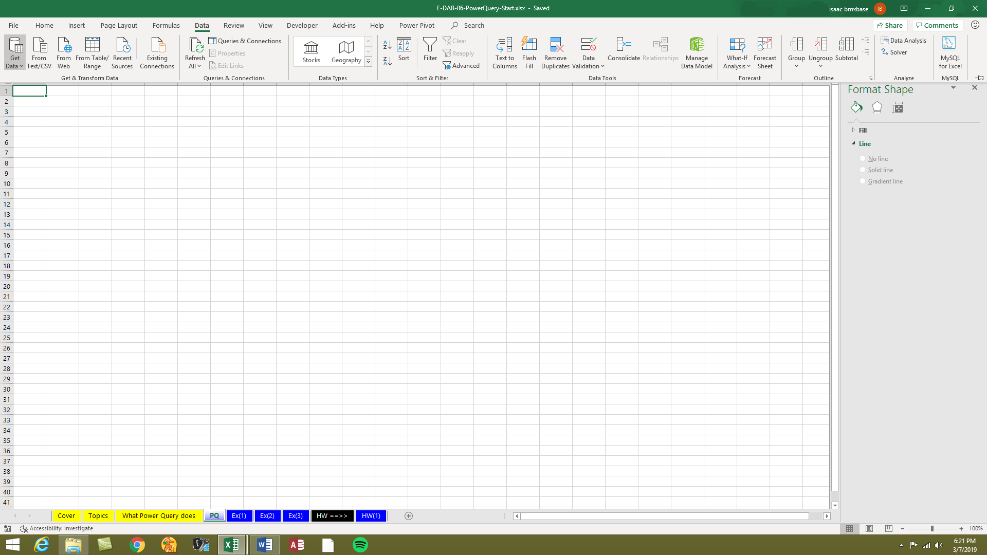
  2. Point to From File, then click on From Text/CSV, as seen below:  
     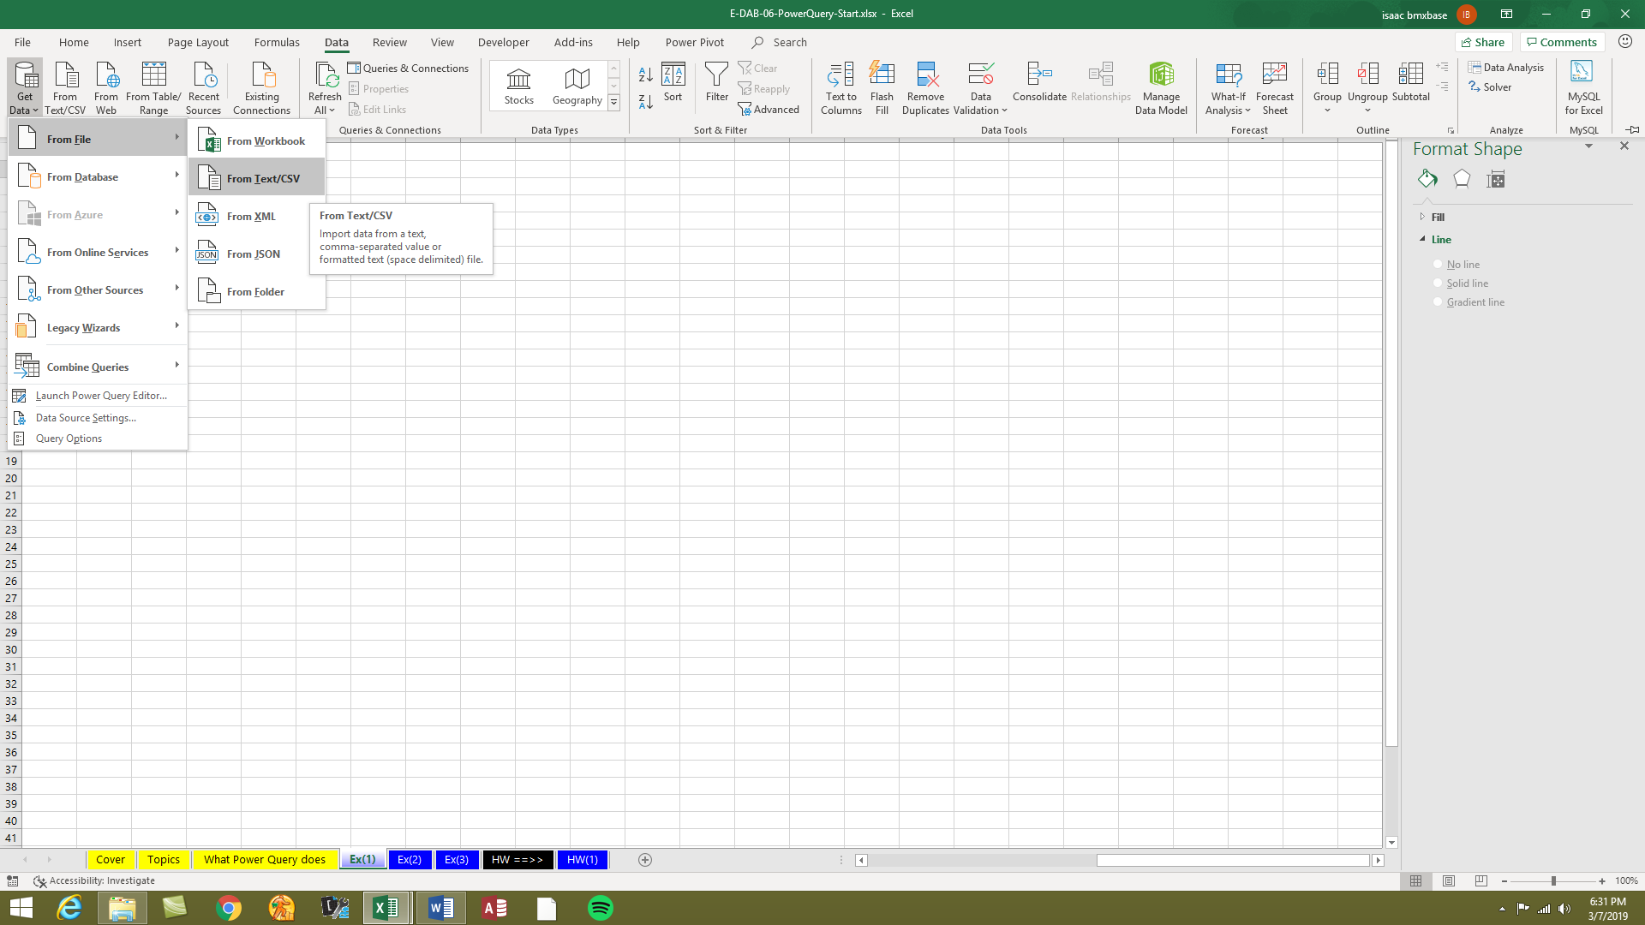
  3. Navigate to the file that you have placed in a designated location (same location you will use next month), click the file, and then click the Import button, as seen below:  
     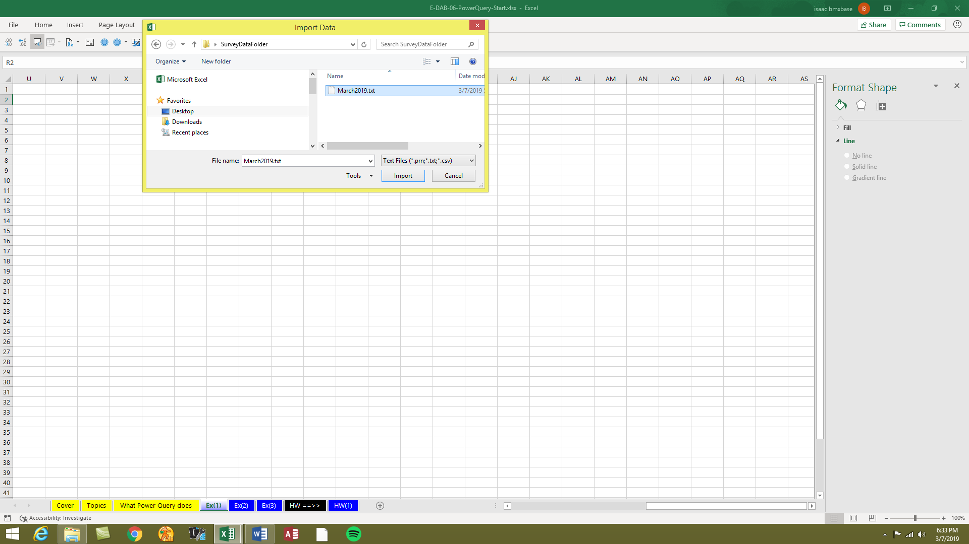
  4. Verify that the Delimiter is Tab and then click Transform Data (in some versions the button says “Edit”), as seen here:
  5. 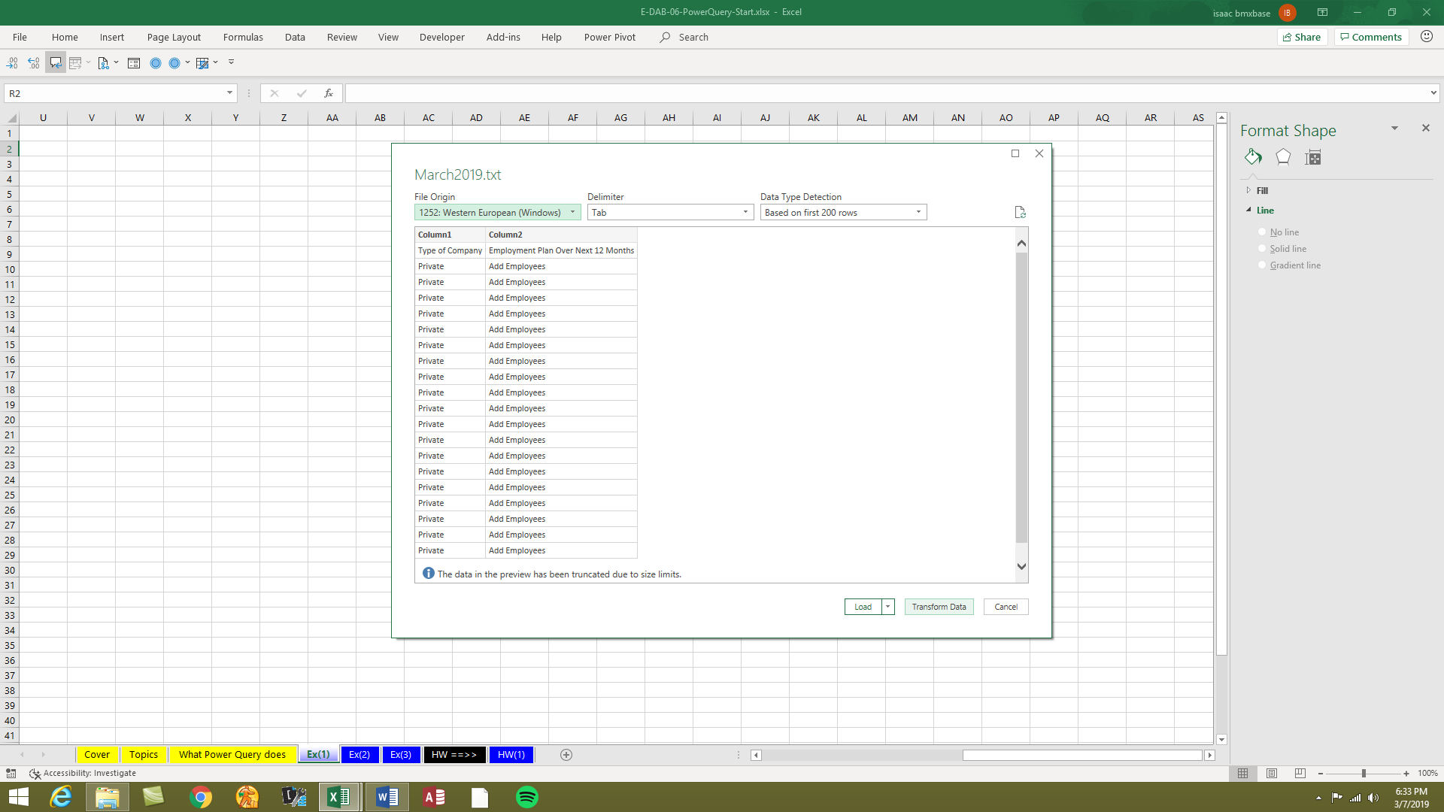

Click Transform Data (in some versions the button says “Edit”)

Verify Delimiter

* 1. The text data has been opened in the Power Query Editor. Name the Query “TextSurveyTable”, and then in the Applied Steps Pane, use the Red X to delete the “Changed Type” step, as seen below:  
       
     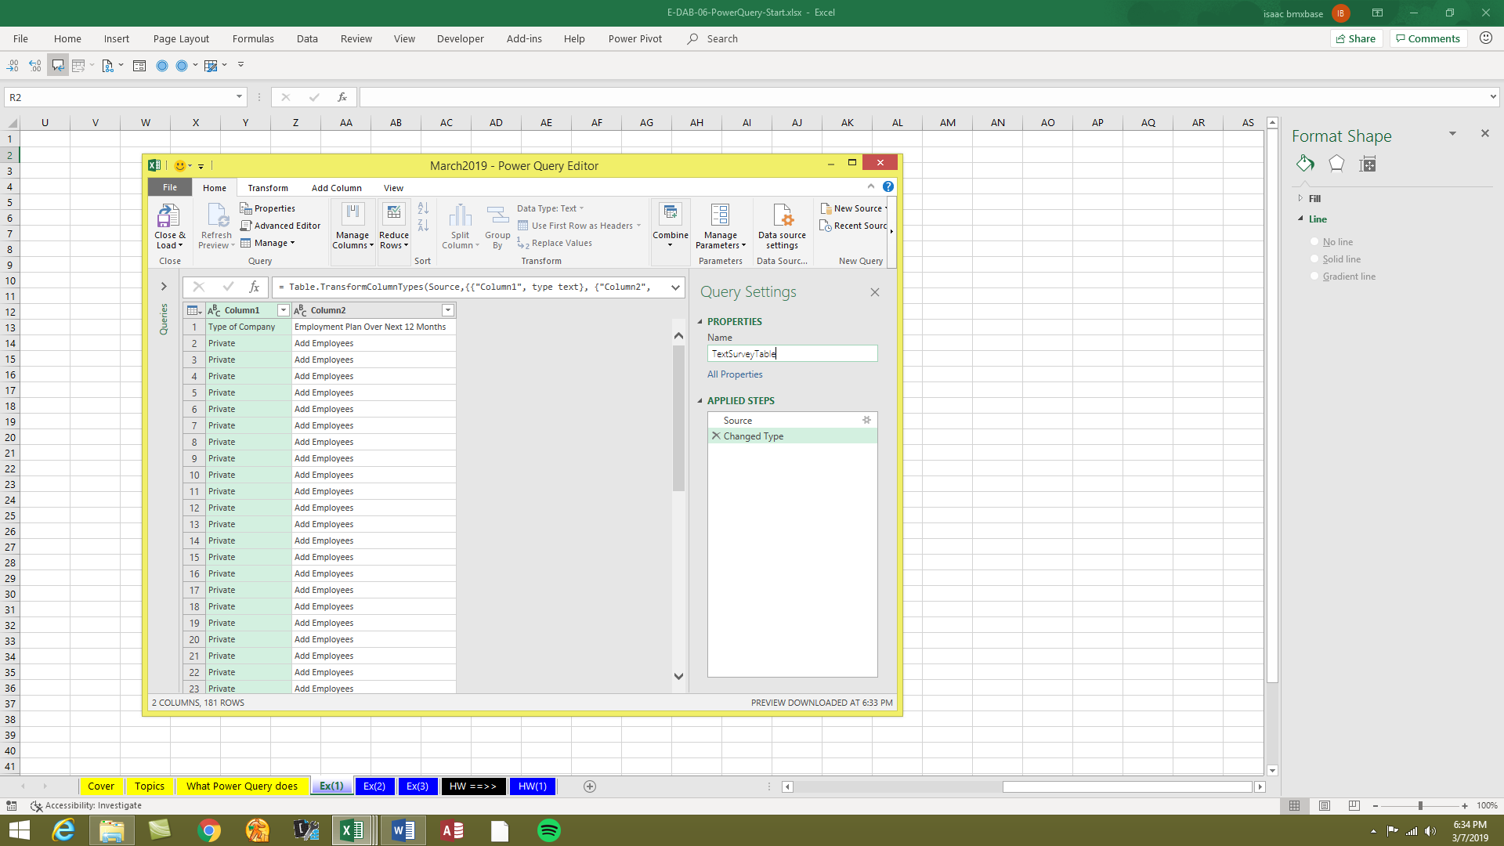

Delete the “Changed Type” step

Name the Query “TextSurveyTable”. In the video we used the name “TextSurveyDataFinalTable”

* 1. In upper left corner of table, click dropdown and the click on “Use First Row as Header”, as seen here:  
     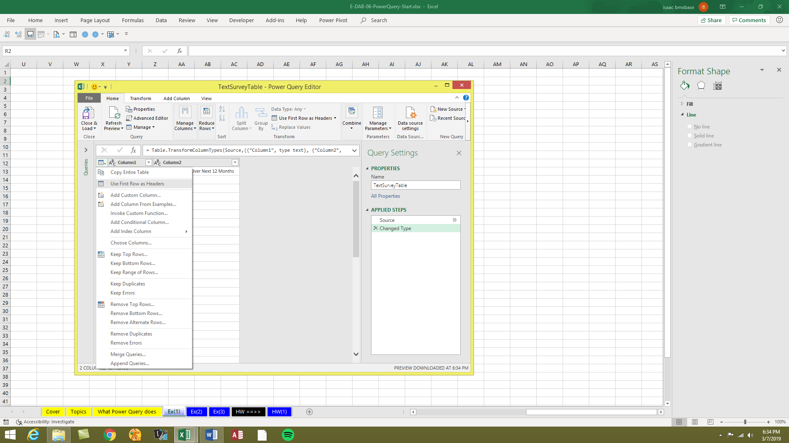
  2. The Applied Steps list should show three steps (as seen below). In the Home Ribbon Tab on the far left, click dropdown for Close & Load, then click on “Close & Load To…”  
     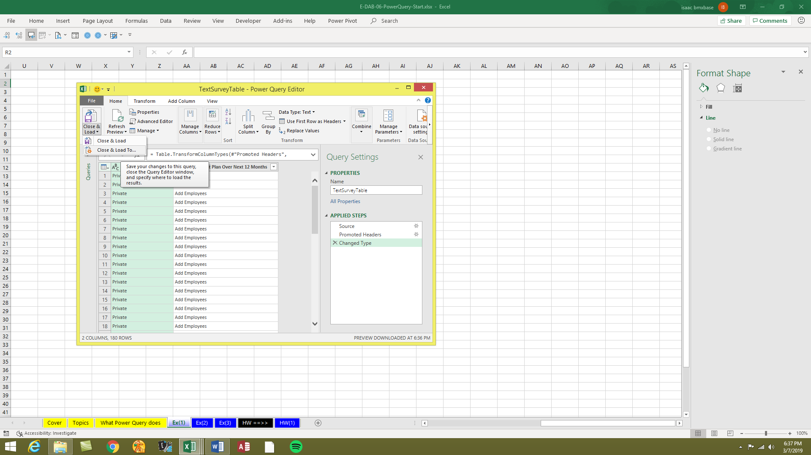

Click on

“Close & Load To…”

Three Steps in Applied Steps list.

* 1. In you have Office 365, you can use the “PivotTable Report” option in the Import Data dialog box to load the data to a PivotTable Cache, as seen here:  
     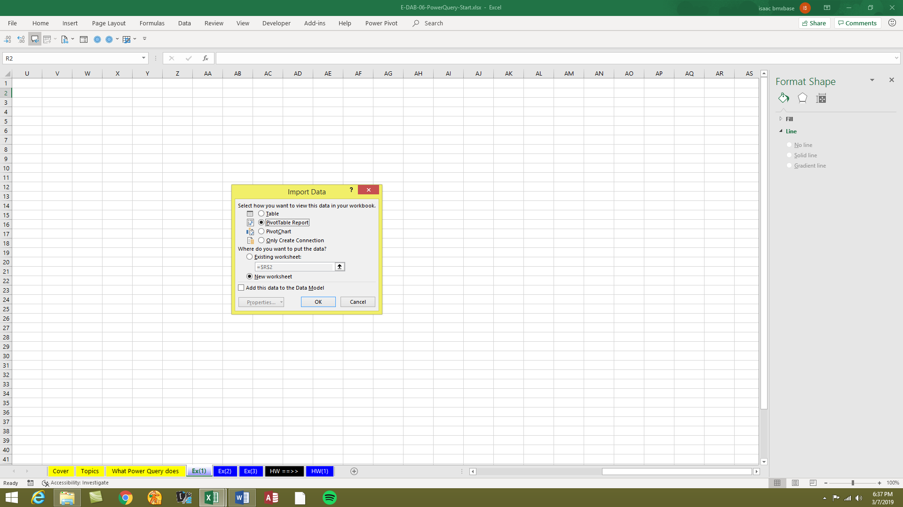
  2. In you do NOT have Office 365, you can use the “Table” option in the Load To dialog box to load the data to a PivotTable Cache, as seen here:  
     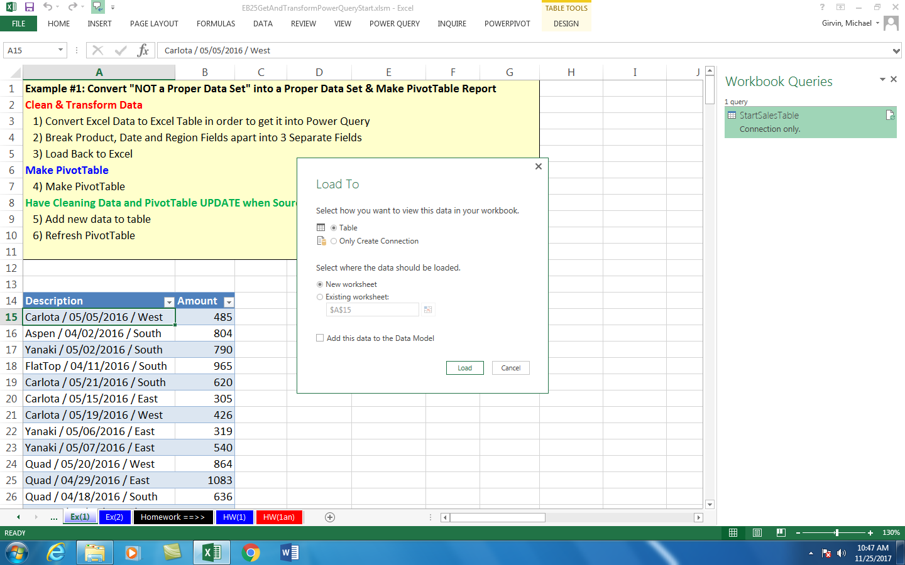
  3. If you load it to the PivotTable Cache, you will see the “Queries and Connections” Pane that lists the query named “TextSurveyTable”, and you will see the PivotTable Field List. 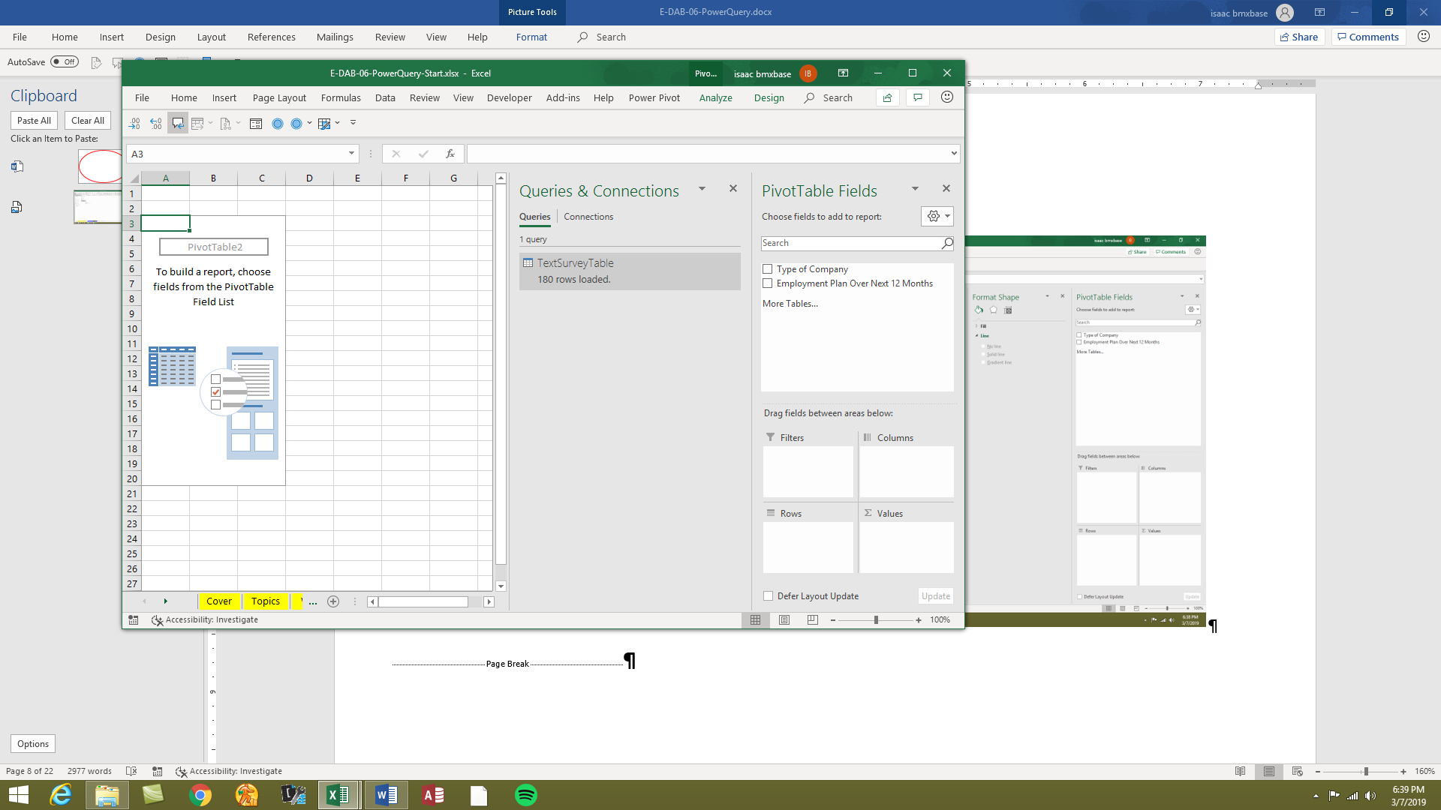

“Queries and Connections” Pane that lists the query named “TextSurveyTable”.

* 1. We can build our PivotTable and PivotChart Report based on the data imported from the text file into the PivotTable Cache, as seen here:  
     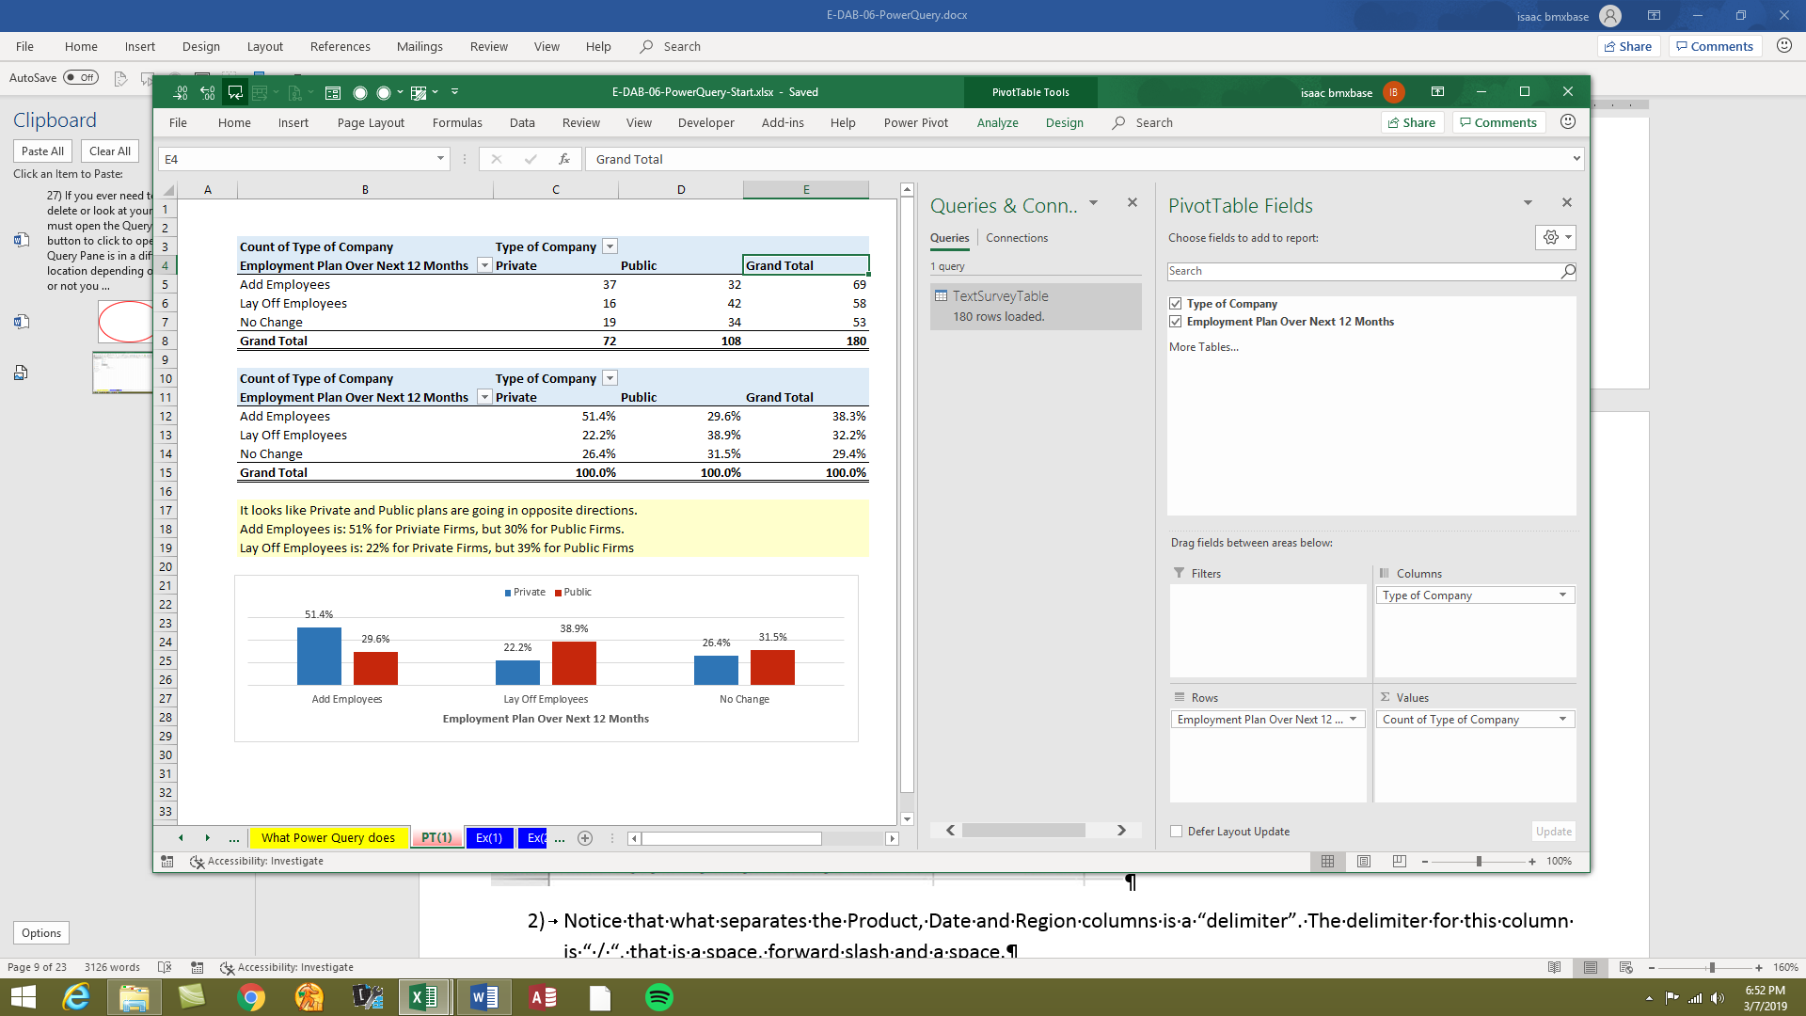
  2. If we do not need to keep a historical record of our report, and next month when we have a new text file in our designated location, we can open the query by double clicking it in the Queries and Connections Pane, as seen below:  
     

Double-click Query to open (or right-click, edit)

* 1. In the Power Query Editor, in the Applied Steps list, double-click the first step named “Source”.  
     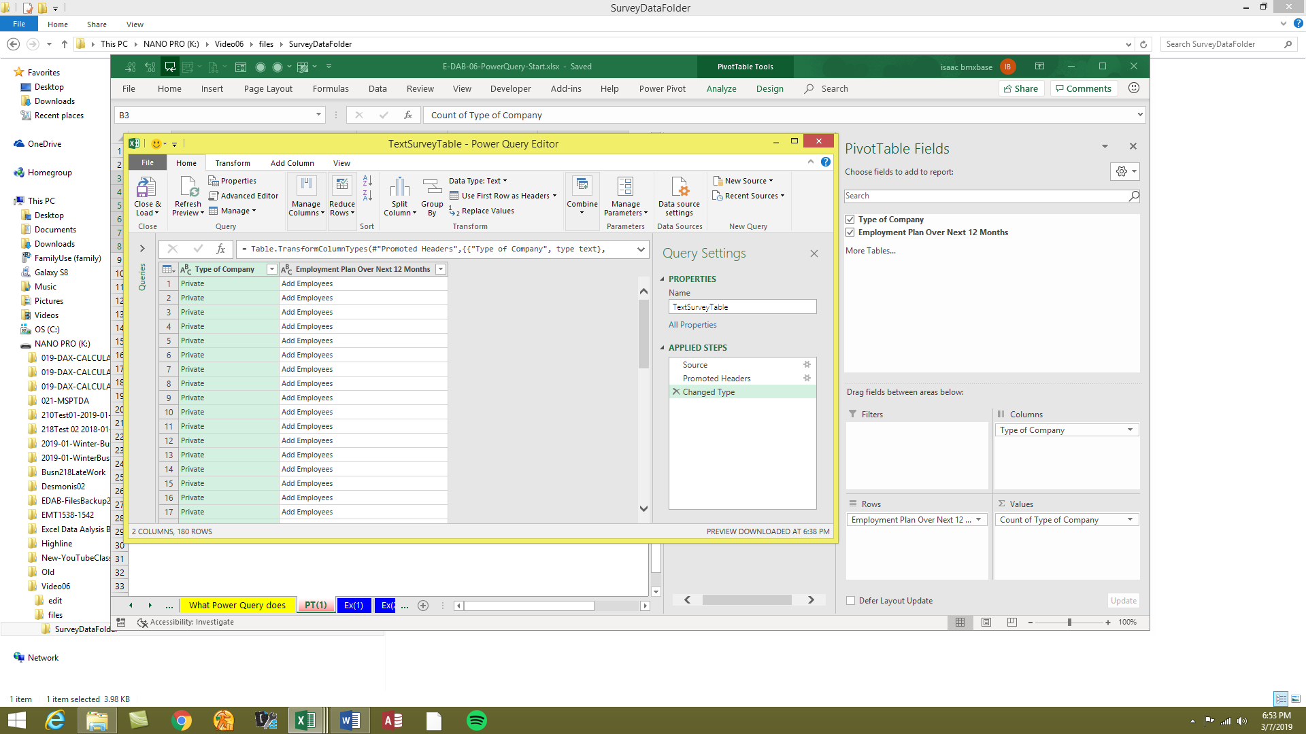

double-click the first step named “Source”.

* 1. The file path looks like this (for March):  
     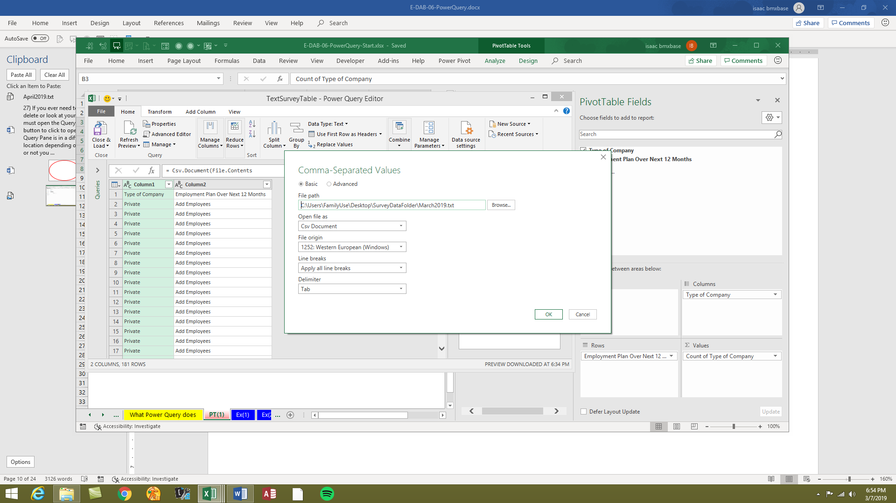
  2. Change the name from March to “April”. Then click OK.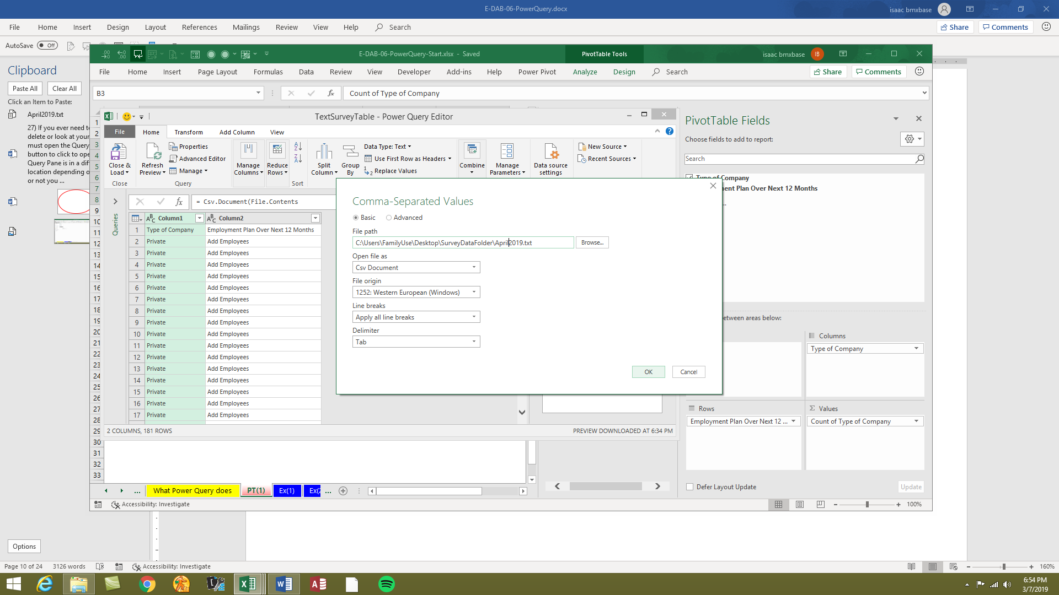
  3. Go back to your PivotTable and Right-click and then point to Refresh. If you loaded the data to the sheet and then built your PivotTable based on the data in the sheet, you will need to refresh the query in the Queries & Connections Pane, then refresh the PivotTable. Here is the updated PivotTable shown here:  
     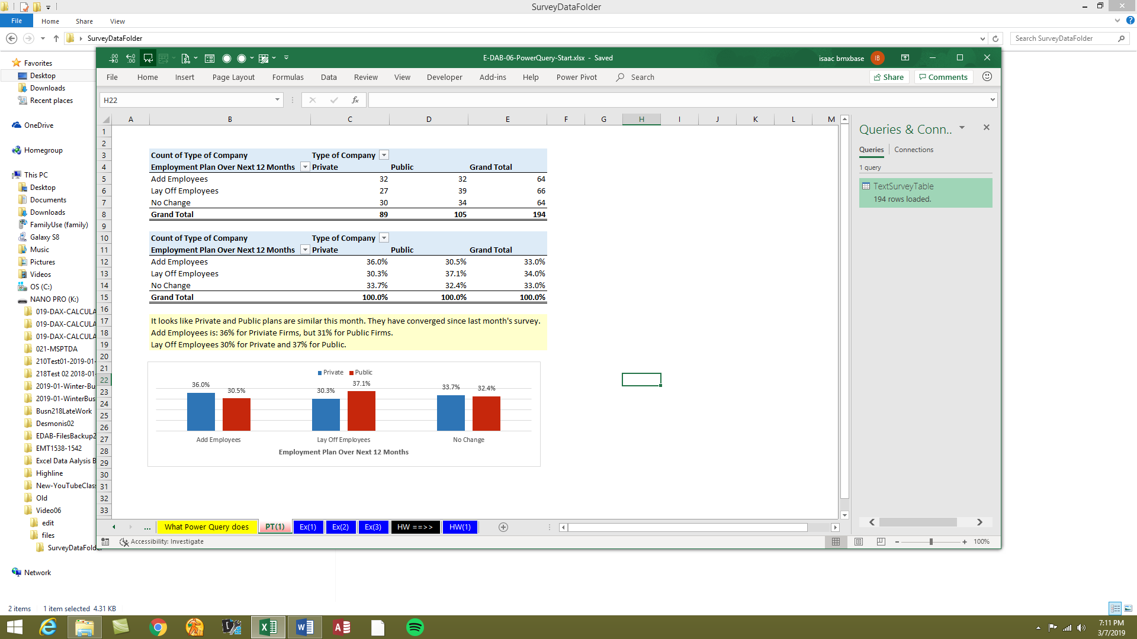
  4. In the video, we also saw how to preserve the historical report, by copying the Query in the Queries & Connections Pane, then edit the source file destination, and then load the new query to a new PivotTable.

# Example 2: Clean and Transform Bad Data For PivotTable

1. On the sheet named “Ex(2)” there is a table with two Columns/Fields named “Description” and “Amount”. The Description column is “Bad Data” because we can’t use the Product, Date or Region in a PivotTable Report unless we break it apart into three columns. This is what the data looks like:

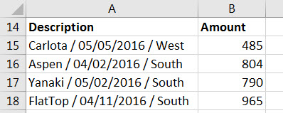

1. Notice that what separates the Product, Date and Region columns is a “delimiter”. The delimiter for this column is “ / “, that is a space, forward slash and a space.
2. In order to use data from an Excel Sheet we must convert the data to an Excel Table. We can convert the table of data to an Excel Table by clicking in a single cell and using the keyboard Ctrl + T. In the Properties group in the Table Tools Design Ribbon Tab we can name the table “StartSalesTable”.
3. To bring the Excel Table into the “Power Query Editor Window”, click in one cell in the Excel Table and in the Data Ribbon Tab, in the “Get & Transform” group, click the “From Table” button:
   1. In Office 365 it looks like this:
      1. 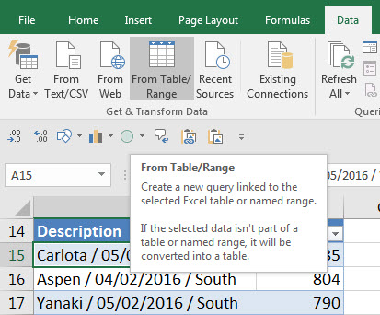
   2. In a version that is NOT Office 365, it looks like this:
      1. 
4. A New window opens up that reads “Query Editor” or “Power Query” in title Bar. On the Right, we want to click in Query Settings Task Pane Name textbox and name the Query “SalesProperDataSet”. This name is the name of the Query and the name of the “Cleaned” Excel Table that will be loaded back into Excel.

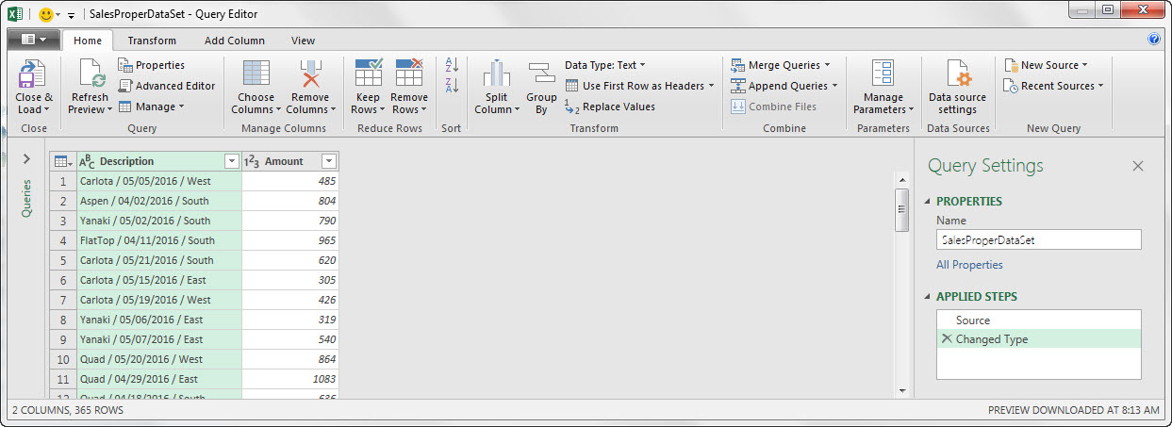

New Window opens called “Query Editor” or “Power Query” (depending on version.

Name of:

1) Query

And

2) Cleaned Excel Table that will be loaded back into Excel

1. Click on the “Description” Column Header to select the whole column

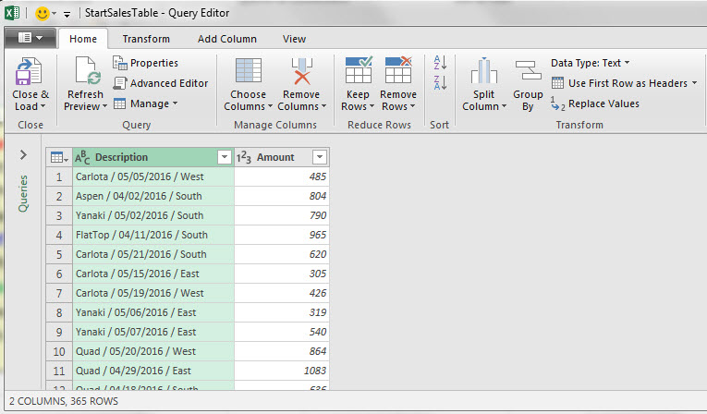

1. Notice that in the Description column, what separates the Product, Date and Region columns is a “delimiter”. The delimiter for this column is “ / “, that is a space, forward slash and a space. Now we need to split the Description column into three separate columns.
2. In the Query Editor Home Ribbon Tab, in the Transform group, click on the Split button and then click on “By Delimiter”:

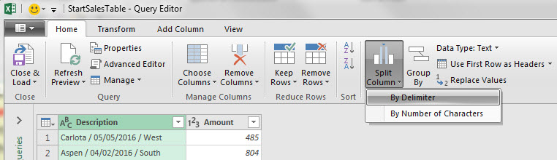

1. The Split By Delimiter dialog box pops up and looks like this:



1. From the “Select or enter delimiter” drop-down, select “Custom” like this:

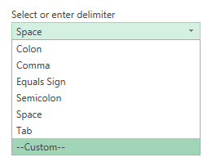

1. Type a space, forward slash and then space, like this:

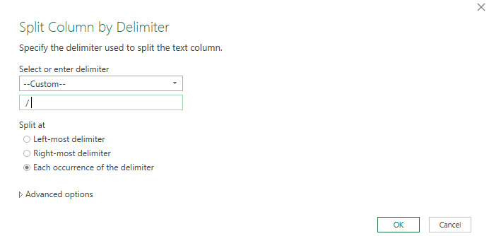

1. After you click OK, the new “split” data set looks like this:

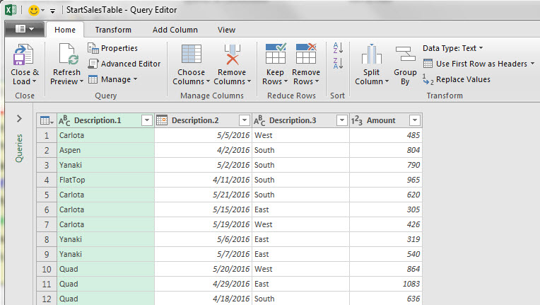

1. Notice that the Column Header / Field Names are not useful names.
2. To rename each Column Header / Field, double click the Column Header / Field Name, type name and hit Enter. The renamed columns should look like this:

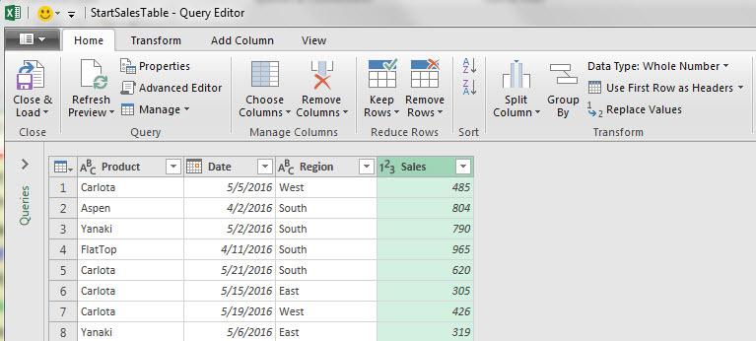

1. Now we want to take a closer look at each Column Header / Field Name and notice the icons like “ABC”, Calendar Icon and “123”. These are the Data Types for each column. These Data Types assure that the right kind of data goes into the column. The Product, Date and Region all have the correct Data Type. But the Sales Field needs to have the Data Type changed to “Currency” Data Type. To do this, click the “123” icon on the left side of the Sales Column Header and then click on Currency, like this:

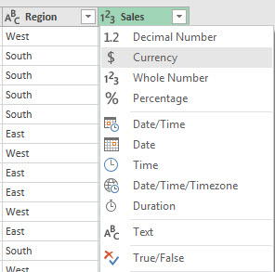

1. Now our Query is finished. Notice that the steps of the query are listed on the right. These steps can be viewed by clicking on them and can be edited if necessary.

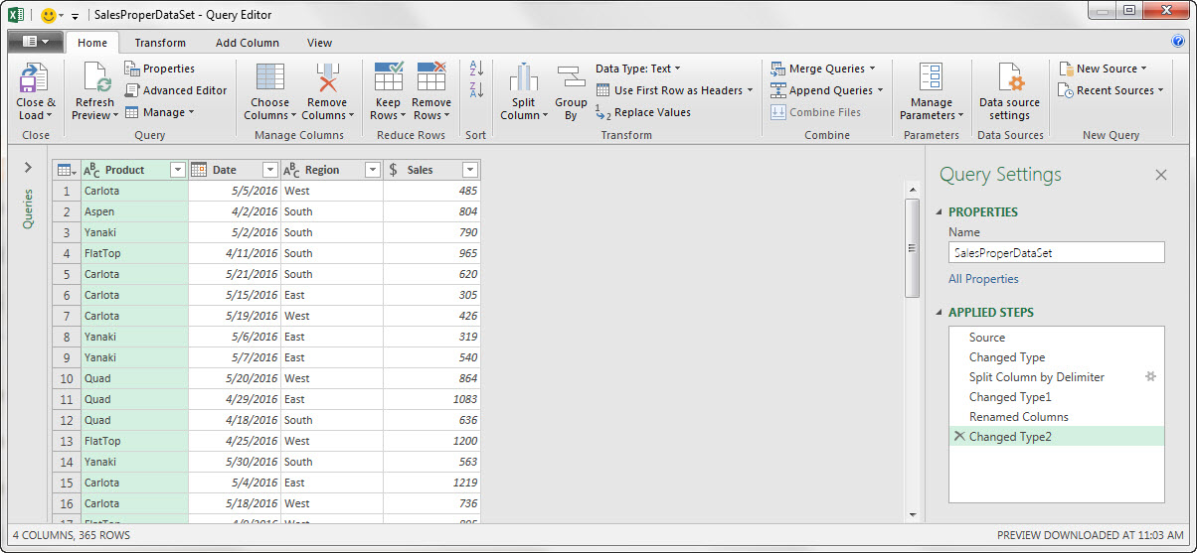

1. To load the Cleaned & Transformed Proper Data Set to an Excel Sheet, in the Home Ribbon Tab, in the Close group (all the way on the left), click the Close & Load drop-down arrow and then click on the “Close & Load To…” option

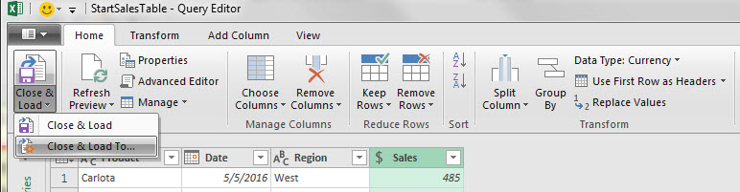

1. The next dialog box that pops-up depends on what version you have:
   1. If you have Office 365, then your dialog box looks like this and is named “Import Data”:

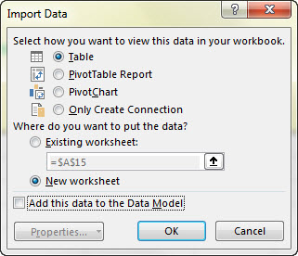

* 1. If you do NOT have Office 365, then your dialog box looks like this and is named “Load To”:



* 1. In either dialog box you now select “Table” and “New Worksheet” dialog buttons.
  2. By selecting the “Table” option we are create a new Excel Table on a new sheet. This Excel Table will be have the same name as the Query and will be the Power Query Output or Result.

1. After the Cleaned & Transformed Proper Data Set is loaded to an Excel Sheet, we can see that the name of the Query and the name of the new Excel Table are the same. They are both named SalesProperDataSet “. After the data is loaded, be sure to name the sheet “Cleaned Data”. Notice that the Query Pane shows that 365 records have been loaded.

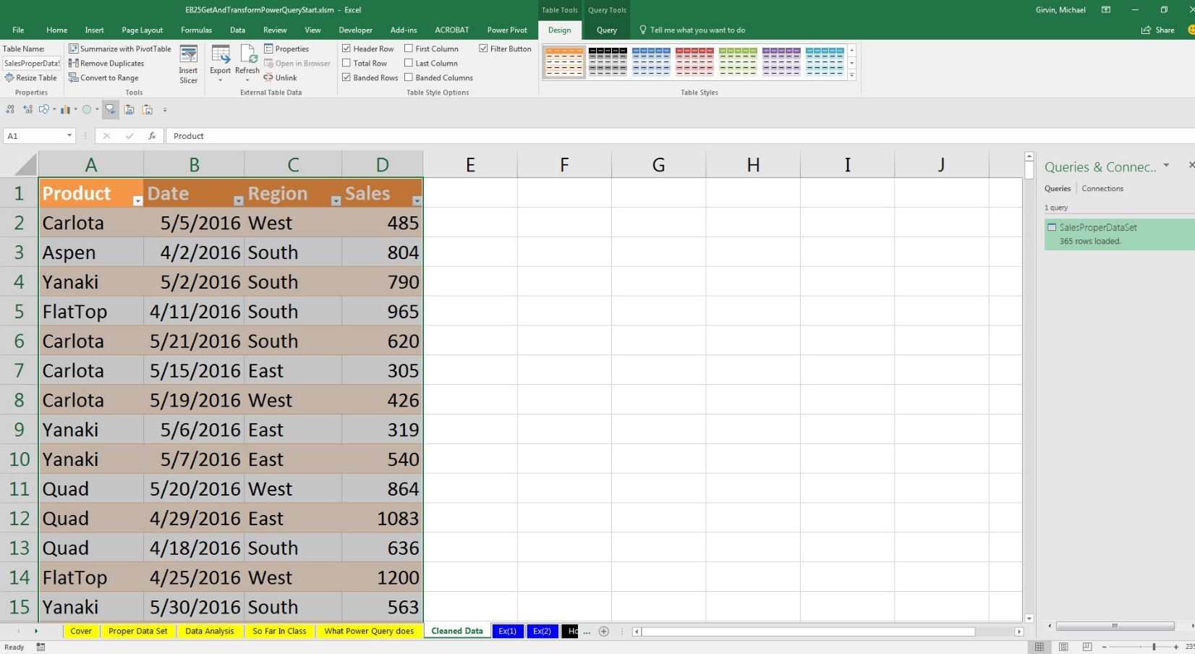

This is called the Query Pane. You may have more Queries listed here.

Same Name for both:

1) Query

And

2) Cleaned Excel Table that is loaded to a new sheet

** It is simultaneously both an Excel Table and the Output from Power Query

Be sure to name sheet “Cleaned Data”

1. Now we can build a PivotTable Report from our cleaned data:

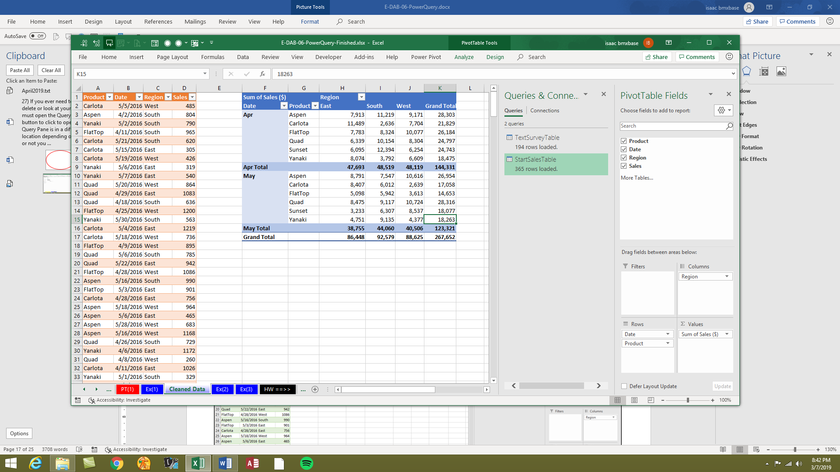

1. Back on the sheet “Ex(2)”, select the new data (new records) in the range AA15:AB130, like in this picture:

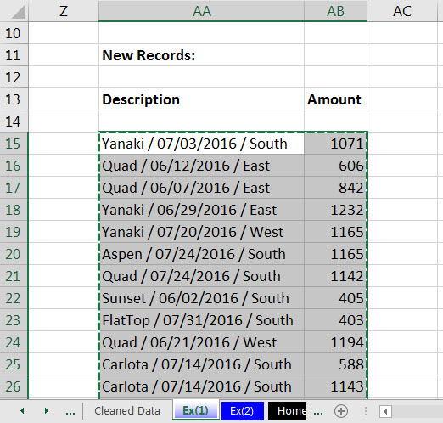

1. Select cell A380 below the original data set, the Excel Table named, “StartSalesTable”, like in this picture:

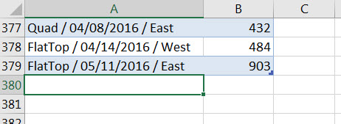

1. Paste the copied new records so they become part of the Excel Table named StartSalesTable””, like this:

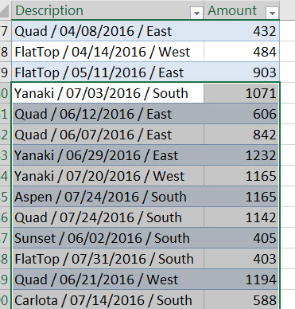

1. Go back to the Query Output, the Excel Table “SalesProperDataSet” with the cleaned data, and then right-click and click on the “Refresh” option. This will update the Power Query Output, which means it will run through all the listed steps in the Power Query window and re-load the complete new data set.

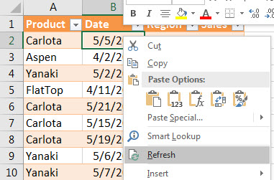

1. Then in the PivotTable, right-click and click on the “Refresh” option. This will refresh the PivotTable Cache Data storage.

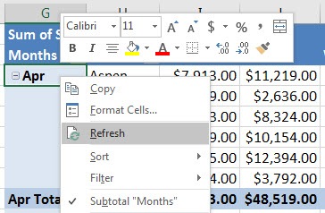

1. The completed project should look like this:

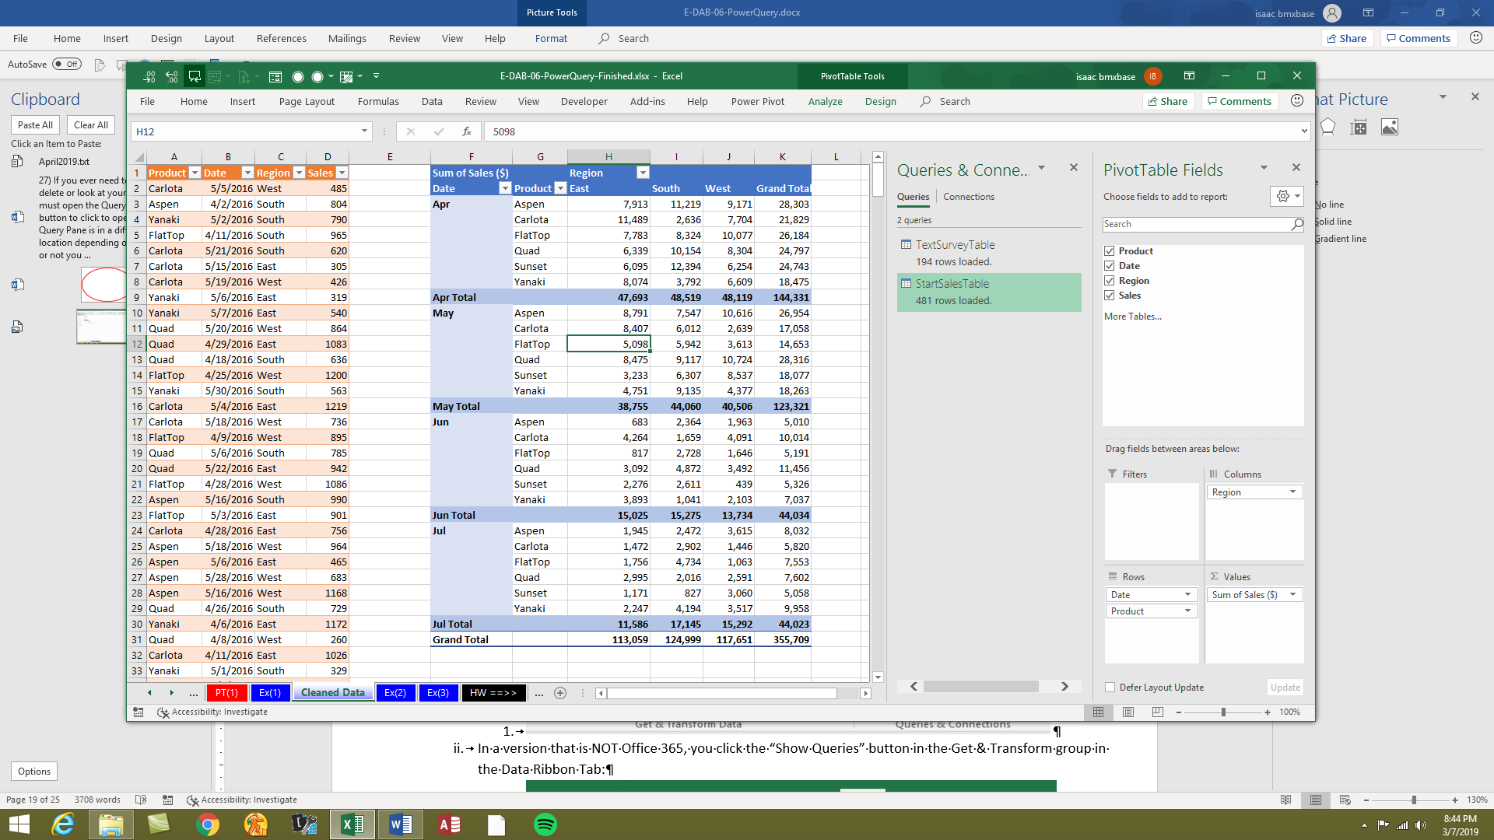

# Example 3: Import Multiple Text Files

1. After you download the zipped folder named “EB25FileDownloads” to the desktop (or some other location) and then unzip the folder, you will see that there are two text files and one folder named “Start” inside, like in this picture:

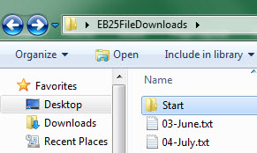

1. If you look inside the Start Folder, you will see two Text Files. This is the folder where we store our Text File data and we only put “.txt” files in this folder. Each file contains the Sales Data for a single month. As seen in this picture:

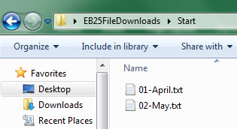

Start Folder is where we store or monthly sales data. We only store “.txt” files in this folder.

1. If you right-click the Text File named “01-April.txt” and click on “Open With”, then click on “Word” you will see this:

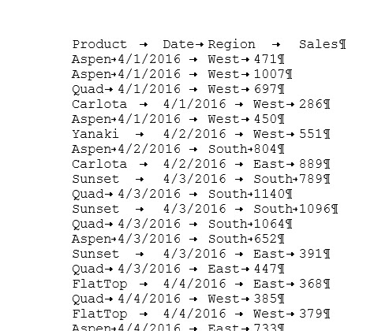

1. Each one of the Text Files has four columns of data, where each column is separated by a Tab delimiter. This means that the Text File contains the columns Product, Date, Region and Sales and each column is separated by a Tab. Tab delimited data is a common way that different systems can share data. This data came from a data storage system that exported monthly data in a Tab Delimited form. This is good for us because Power Query can easily interpret Tab Delimited data and can easily combine the different Text Files into a single Proper Data Set.
2. Our goal is to combine (sometimes referred to as “append”) the text files into a single Proper Data Set.
3. Go to the sheet named “Ex(3)” and select cell A11. Then in the Data Ribbon Tab, in the Get & Transform Group start a new query to import the Text Files from a Folder. How we start a new query to import from a folder depends on the version you have:
   1. In Office 365, you click the “Get Data” button in the Get & Transform Data group in the Data Ribbon Tab:



* 1. In a version that is NOT Office 365, you click the “New Queries” button in the Get & Transform group in the Data Ribbon Tab:



1. From the drop-down, you select “From File” and then click on “From Folder”, like in this picture:

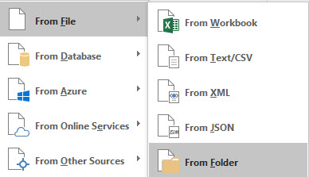

1. Click in the Browse textbox, then click on the Browse button, and navigate to the Start Folder, like in this picture:

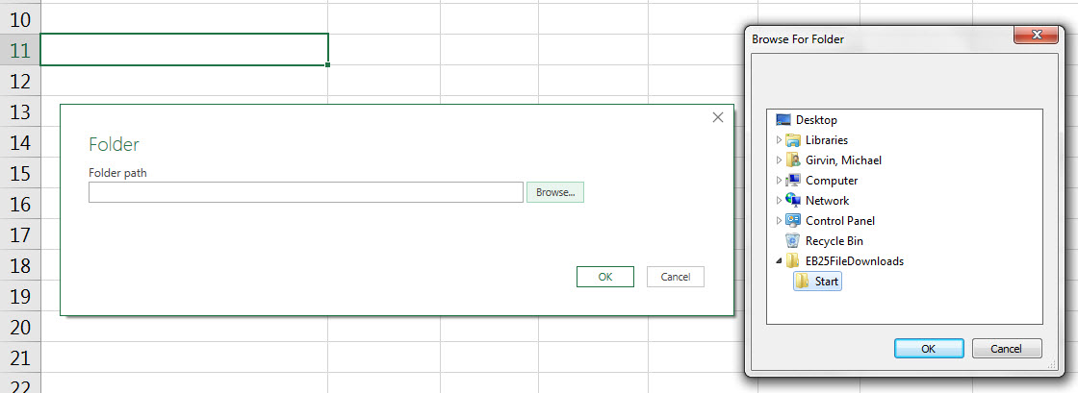

When we point to the Start Folder, Power Query will try and import all files from this folder.

1. Click OK in the “Browse For Folder” dialog box. Click OK in the “Folder” dialog box.
2. In the next dialog box, select the Combine button drop-down and then select “Combine and Edit”, like in this picture:

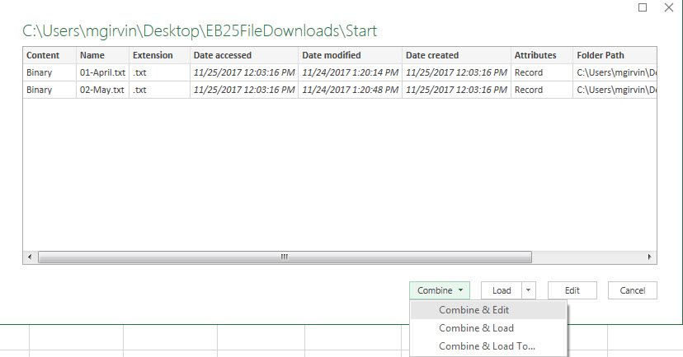

1. In the next dialog box, make sure that the Delimiter is Tab. If it is, click OK.

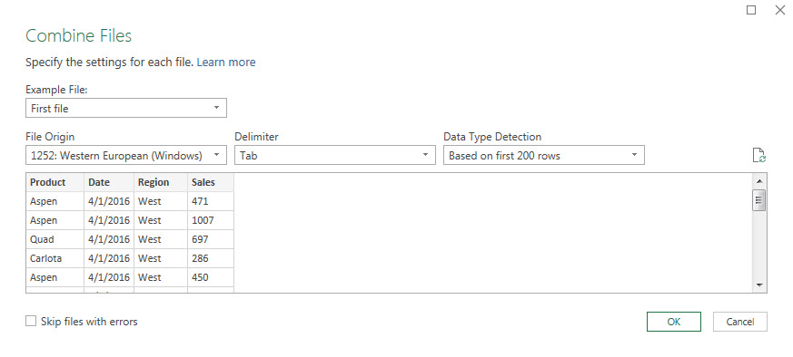

1. When the Query Editor comes up, name the query “MonthlyTextSalesProperDataSet””, as seen here:

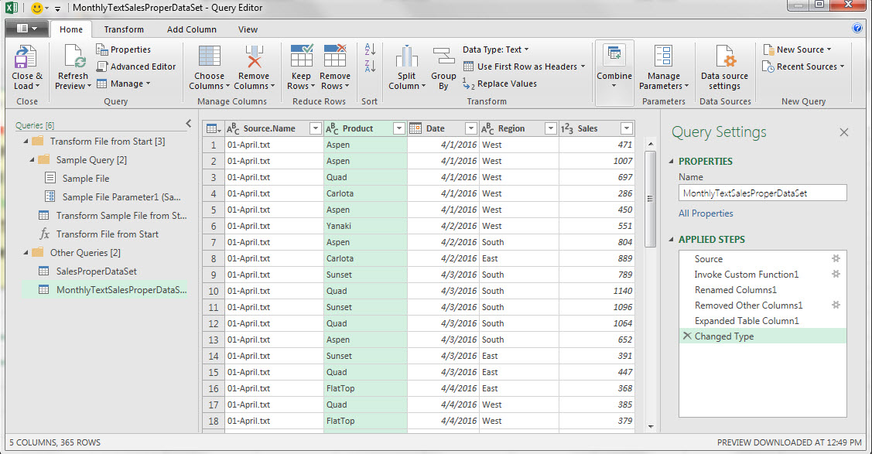

1. Right-click Source.Name Column Header and then click on Remove, like seen here:

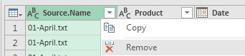

1. Change the Data Type for the Sales Field to Currency, like in this picture:

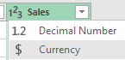

1. The finished query should look like this:

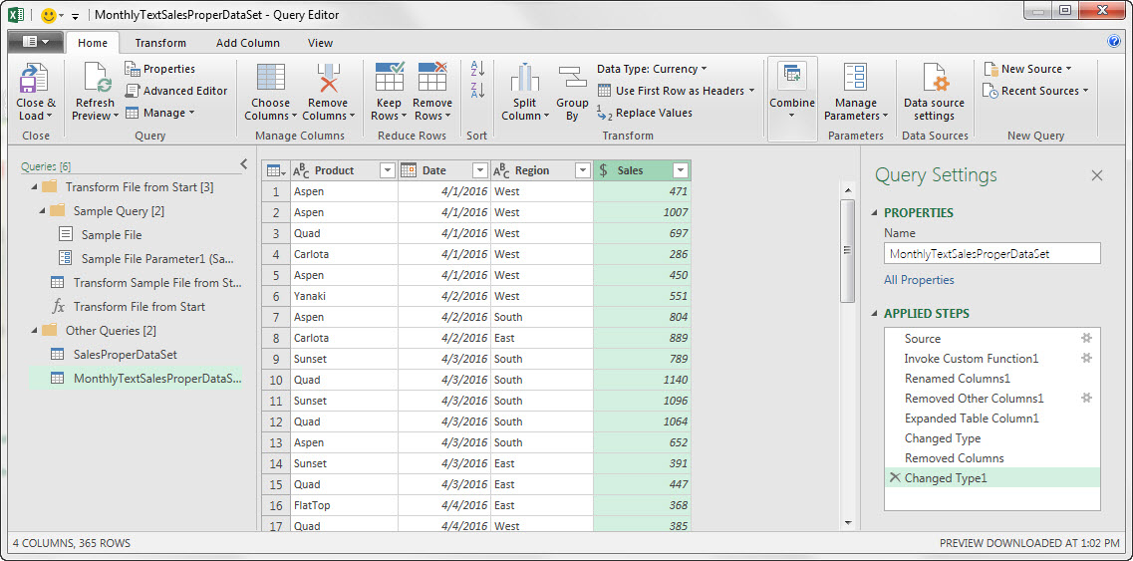

1. From the Home Ribbon Tab, in the Close group, click the Close & Load drop-down and then click on Close & Load option, like seen here:

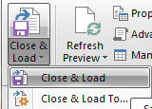

1. When the new table loads, be sure to name the sheet “CleanedTextData”. In the Queries Pane you can see a lot of steps that were automatically created to combine the text files. At the bottom of the Queries Pane you can see the two queries that we created and you can see the number of rows that were loaded.

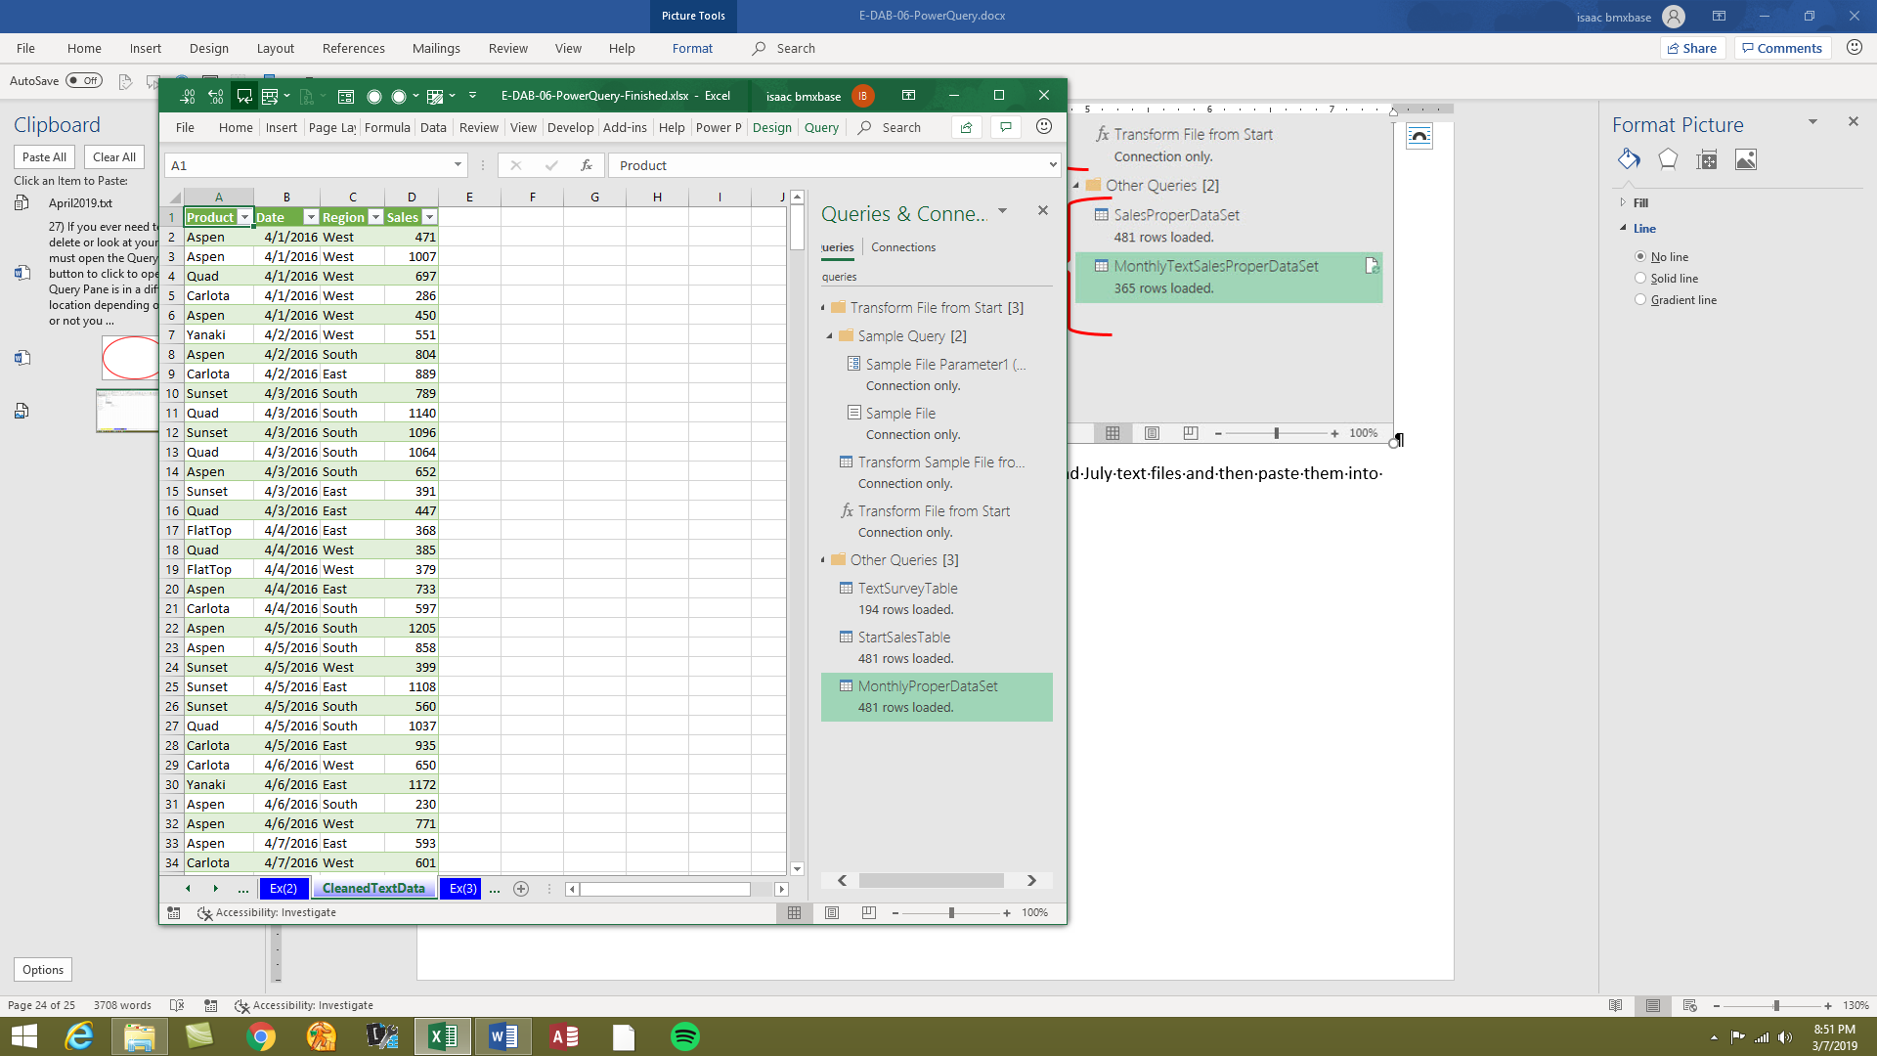

These are the three queries that we created. You may have more queries listed here.

Lots of steps automatically created by Power Query to combine Text Files.

Name the sheet “CleanedTextData”

1. Now go back to the “EB25FileDownloads” folder and copy the June and July text files and then paste them into the “Start” folder, like seen here:

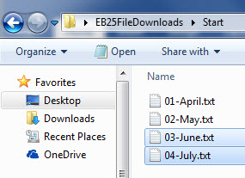

1. Now go back to the “MonthlyTextSalesProperDataSet” Power Query Output and right-click and then click on the “Refresh” option. In the Queries Pane you will see that the new Text Files for June and July have been included in the Table:

